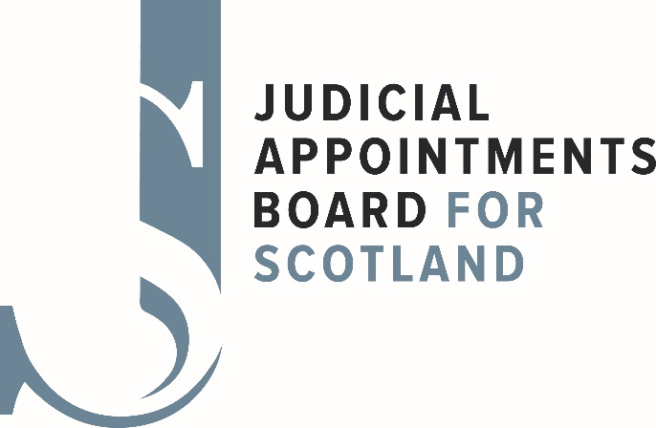

**Business Plan 2025 – 2026**

28 April 2025

**Introduction**

This annual plan sets out what we plan to deliver over the 2025/6 financial year.

JABS work is demand led, responding to requests for judicial competitions from the Scottish Government. Jabs is working with the Scottish Government and the Judicial Office for Scotland, part of the Scottish Courts and Tribunals Service to develop a three-year planning cycle for judicial appointments in Scotland.

This Plan identifies the actions that we intend to undertake during 2025/26 to achieve our objectives as set out in years two and three of our 2023– 2026 Corporate Plan which was published in September 2023. Progress on the delivery of the Business Plan will be reviewed quarterly by the Board and will reflect changes in the demands placed on JABS for judicial competitions during the year ahead.

In previous years we created a Diversity Action Plan. Work continues to deliver on that plan with the assistance of the Judicial Appointments Diversity Reference Group and the allied Data Subgroup. This work will be informed by a clear understanding of JABS obligations under the Judiciary and Courts (Scotland) Act 2008. There will be a greater focus on communications and outreach activity in the year ahead with the legal profession and the wider public at large.

The culture of continuous improvement remains strong with a number of corporate as well as operational improvements already embedded in our policies and processes. We will continue to make progress on our Programme for Change which is looking at all aspects of how we undertake our judicial appointment competitions. A number of our Board Members and Appointment Advisers will assist with progressing this work. Feedback from the judiciary, legal professional bodies, as well as post competition surveys of candidates for judicial office will further inform this work.

This Plan, informed by outputs from the JABS Strategy Day, will ensure that we utilise our most important assets – our Board members, legal and lay appointment advisers, our staff in the Business Management Unit (BMU) and our relationships with our key stakeholders.

Under Schedule 1 Section 14(1) of the Judiciary and Courts (Scotland) Act 2008, ‘The Scottish Ministers must provide, or ensure the provision of such staff, property and services as they consider the Board requires for the purpose of carrying out its functions.’ A draft budget for the 2025/6 financial year, which will support this plan of work, has been shared with the Scottish Government.

JABS Priorities

Based on the Corporate plan ( September 2023-August 2026)

Year 2

* Implement revisions to our operating model to make best use of the new resources available to JABS, in particular in the Scottish Tribunals competitions
* Continue to review our approach to outreach, applications and assessment as part of the Programme for Change
* Undertake survey research work to inform process improvements as part of the Programme for Change
* Continue with the development, with the SG and JO, a Joint planning approach to the timing and management of judicial appointment competitions, taking into account the new budgetary climate
* Work with key stakeholders to implement the diversity action plan for judicial appointments
* Undertake a programme of increased external engagement to further public knowledge of JABS and the judicial appointments process
* Develop a process for actively monitoring outputs, including the collection of statistical information to better inform approaches
* Carry out a review of staffing and resources as soon as a 3 year recruitment plan is agreed with SG.

**Year Three**

* Enhance understanding of the work of JABS amongst the judiciary, the legal profession and the public at large
* Framework Agreement between JABS and the Scottish Government reviewed
* Review effectiveness of the changes to our systems and processes introduced in the first two years of the plan

Actions 2025/26

**Appointments**

* Conclude recruitment activities for Sheriff 2025, five chambers of the First-tier Tribunal for Scotland and the Upper Tribunal.
* Begin planning for priority recruitment in the early part of 2025/26 including recruitment for the Office of Sheriff Principal and two Chamber Presidents of the First-tier Tribunal for Scotland. Urgently agree with the Scottish Government the other priority competitions to commence in 2025/26
* Agree a protocol with the new Lord President, the President of the Scottish Tribunals and Scottish Government for a planned programme of recruitment going forward to 2027/8.
* Develop with our key partners a more strategic approach to judicial appointments.

**Programme for Change**

Pull together the various strands of JABS Programme for Change, to the application and assessment process by end 2025/26 and to agree a programme for implementing these.

Consider feedback from applicants at all stages of the judicial recruitment process to further enhance outreach and learning activities to better support future applicants as well as helping improve our processes

Consider revisions to our operating model including use of qualifying tests, roleplay assessments, case-studies etc

In the second quarter of the year, an efficiency and effectiveness review will be undertaken, considering the competition documentation and technological upgrades such as the Applicant Tracking System.

In the first quarter of the year a new Character and Conduct Committee will be set up.

In the second half of the year, we will review the Board’s committee structure and oversight arrangements for competitions.

**Governance and Assurance**

Continue the ongoing programme of review of all JABS corporate and operational policies and augment where required , based on sound legal advice and changing circumstances whether that be legislative, governmental or societal

Discuss and agree with SG appropriate revisions to the Framework Agreement and finalise by end 2025.

Consider options for monitoring or measuring outputs and outcomes for the work of JABS

Governance review to conclude by June 2025

* Publish the JABS 2024/5 Annual Report by September 2025.
* Develop a more robust competition costing and budgeting model.

**Diversity**

* + - * + Build a consensus among the members of the Judicial Appointments Diversity Reference Group (DRG) about options for supporting wider diversity in the judicial appointments for recommendation to the Board
        + Undertake more outreach work including jointly with members of the DRG, based on identified gaps in the eligible cohort of legal and other professional candidates applying for judicial office.
      * Undertake additional work to better understand the makeup and demography of the legal profession driving judicial recruitment statistics
      * Publish JABS new diversity report in 2025 and thereafter annually.

**Information Systems and Digital Resources**

* + - * Complete the ongoing review and implementation of JABS Records Management Plan following feedback from the Keeper.
      * Develop and populate the new JABS website

**Staff requirements**

* Review staff requirements to support the substantial programme of judicial appointment competitions envisaged for 2025/6 and beyond and recruit to agreed complement.

**Engagement**

* Produce a revised communication strategy to cover stakeholder and wider public engagement, outreach, website and social media presence.